IDEATION PHASE – DOCUMENT 3:
EMPATHY MAP CANVAS
Date | 06 November 2025
Team ID | NM2025TMID06186
Project Name | Lease Management
Maximum Marks | 4 Marks

Title: Empathy Mapping for “Lease Management”

1. Objective
The goal of this empathy mapping phase is to understand the emotions, motivations, and challenges of every stakeholder involved in the Lease Management system — including tenants, landlords, property managers, and administrative staff.
By mapping what each user Says, Thinks, Does, and Feels, we can design a more human-Centered Lease Management application that solves real problems instead of just storing rental data.

2. Stakeholders Identified
The empathy map focuses on four key user personas in the Lease Management ecosystem:
Persona | Role | Goal | Pain Points
Tenant | Rents property | Clear, simple rent & lease process | Hidden charges, manual paperwork, delayed updates
Landlord / Property Owner | Leases property | Get rent on time & track tenants | Rent delays, no proper record system
Property Manager | Handles multiple rental units | Monitor leases, payments, renewals | Manual tracking, reminders, spreadsheets
Admin / Accountant | Manages bills & compliance | Maintain clean audit and payment logs | Data mismatch, lost documents, no history

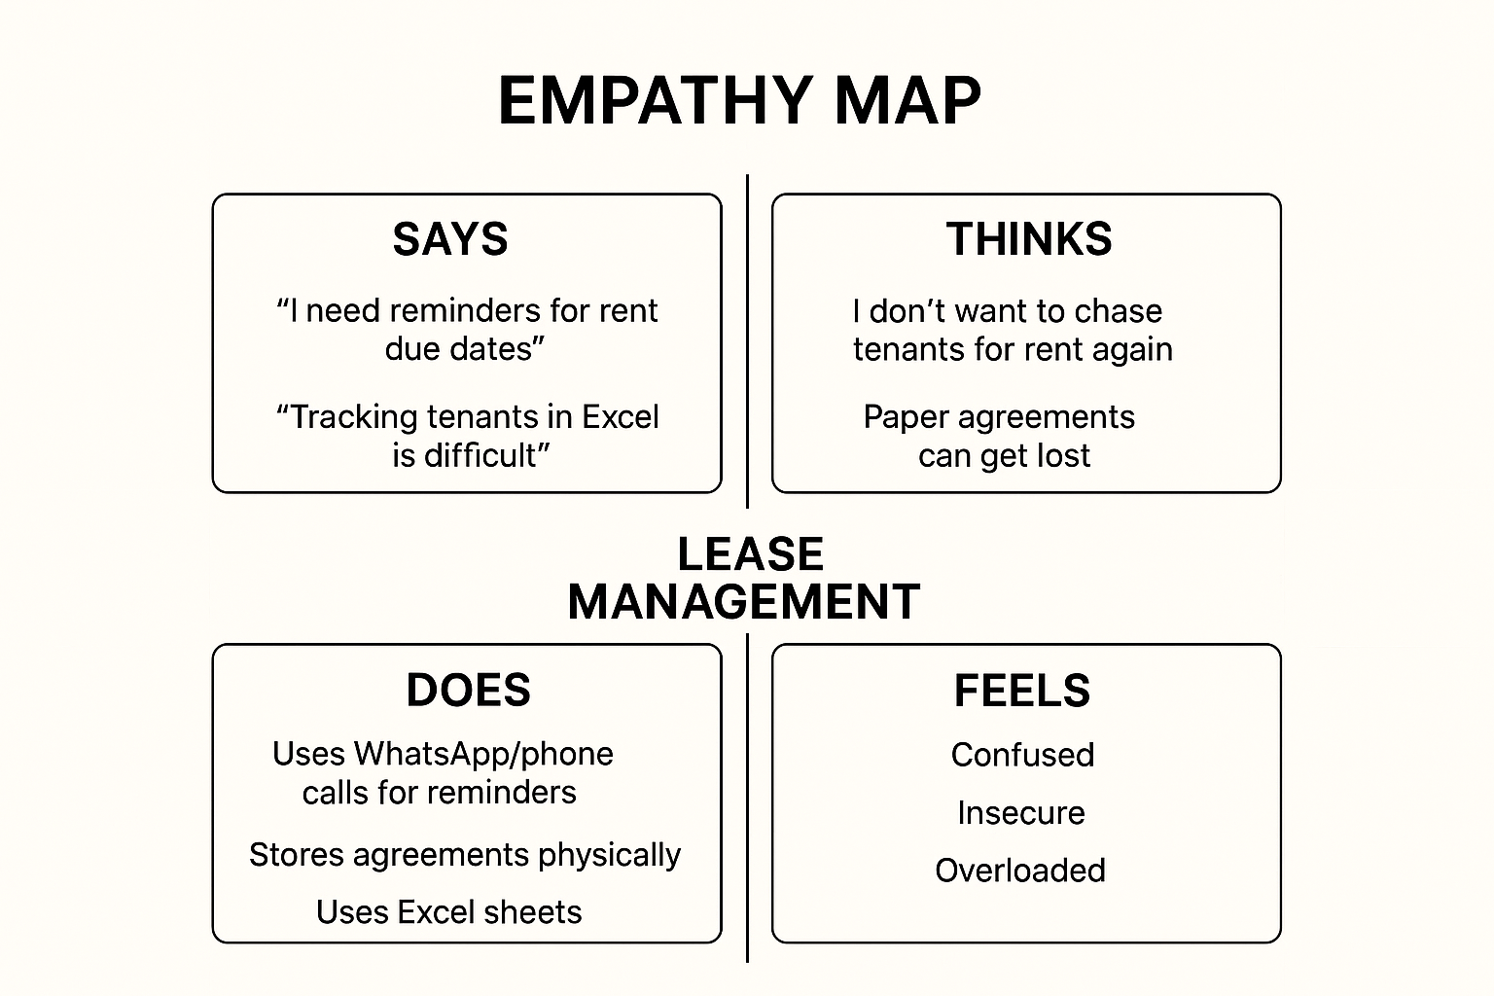

3. Empathy Map Canvas Layout
Below is the empathy mapping framework applied to all four personas.

Quadrant | Description | Key Insights
SAYS | What users express verbally during interaction or interviews | “I need reminders for rent due dates.” / “Tracking tenants in Excel is difficult.”
THINKS | What users think internally but may not openly share | “I don’t want to chase tenants for rent again.” / “Paper agreements can get lost.”
DOES | Actions or behaviours users perform | Uses WhatsApp/phone calls for reminders, stores agreements physically, uses Excel sheets
FEELS | Emotional state, frustrations, and aspirations | Tenants feel confused, landlords feel insecure, managers feel overloaded and stressed

4. Empathy Map Analysis
By mapping these insights, several key observations were made:
- Emotional Connection:
Tenants and landlords both feel anxious due to unclear rent status and lack of transparency.
- Behavioural Pattern:
Most stakeholders still depend on manual processes like paper files, phone reminders, or spreadsheets.
- Cognitive Gap:
Stakeholders know digital solutions exist, but lack automation and centralization.
- Pain Point Highlight:
Admins struggle with rent history, document tracking, renewal reminders, and legal compliance.

5. Insights Derived
From the empathy mapping exercise, five actionable insights were derived:
- Automation reduces workload.
Users want automatic reminders for rent, expiry, and documents.
- Transparency builds trust.
Rent status, tenant history, and payment logs must be visible.
- Centralization increases efficiency.
One dashboard for all leases, tenants, and payments is needed.
- Digital documentation prevents risk.
Paper contracts can be lost or damaged.
- Alerts = peace of mind.
Notifications reduce manual follow-ups and conflicts.

6. Design Implications for Lease Management
Insight | Design Decision
Rent delay issues | Add automated rent reminder system
Document tracking problems | Enable digital agreement upload & expiry alert
Manager workload | Create lease dashboard with active, expired, pending leases
Tenant confusion | Provide tenant portal with rent history & bills
Owner transparency need | Auto-generate report showing rent received & pending

7. Empathy Map Canvas Summary
The empathy map revealed that the success of a Lease Management System depends not only on storing lease data, but on reducing stress, improving clarity, and building trust among all stakeholders.
A well-designed Lease Management solution will:
- Automate reminders & renewals
- Track rent and documents in real time
- Reduce manual effort for managers
- Improve tenant–owner transparency
- Provide audit-ready records for admin

In short, empathy mapping transformed Lease Management from a basic record system into a user-driven, trust-building solution.

